1. Pre-requisites
2. SMAT files are uploaded to a SharePoint documents library:

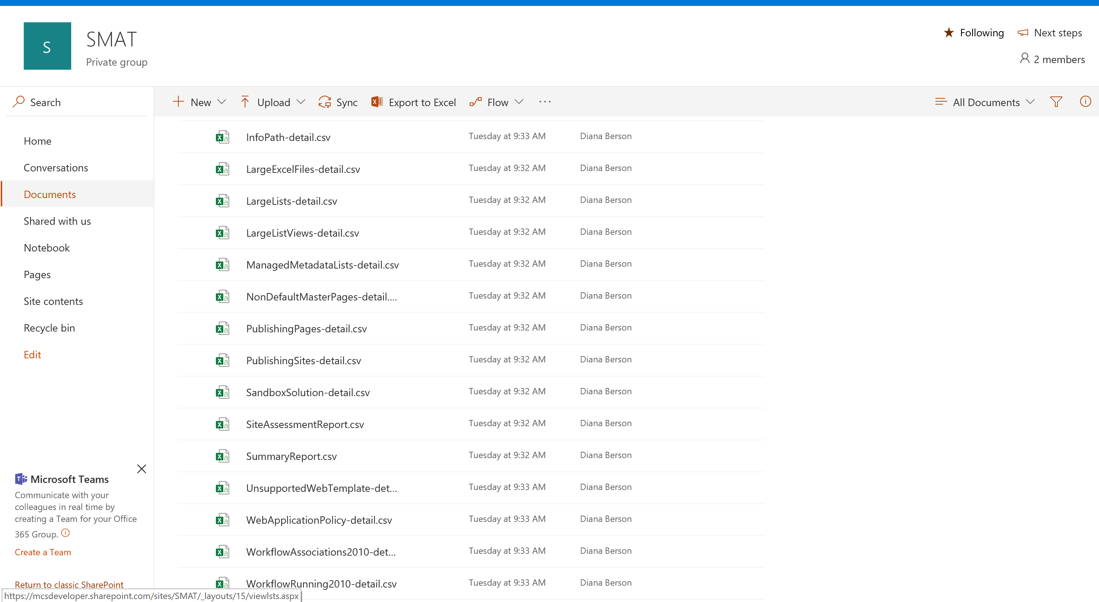

1. You have the latest version of [Power BI Desktop](https://powerbi.microsoft.com/en-us/desktop/).
2. Power BI
3. Open [Power BI Desktop](https://powerbi.microsoft.com/en-us/desktop/) and Import the Power BI template for the custom Help Desk Power BI report (ContosoSMATReportTemplate.pbit).

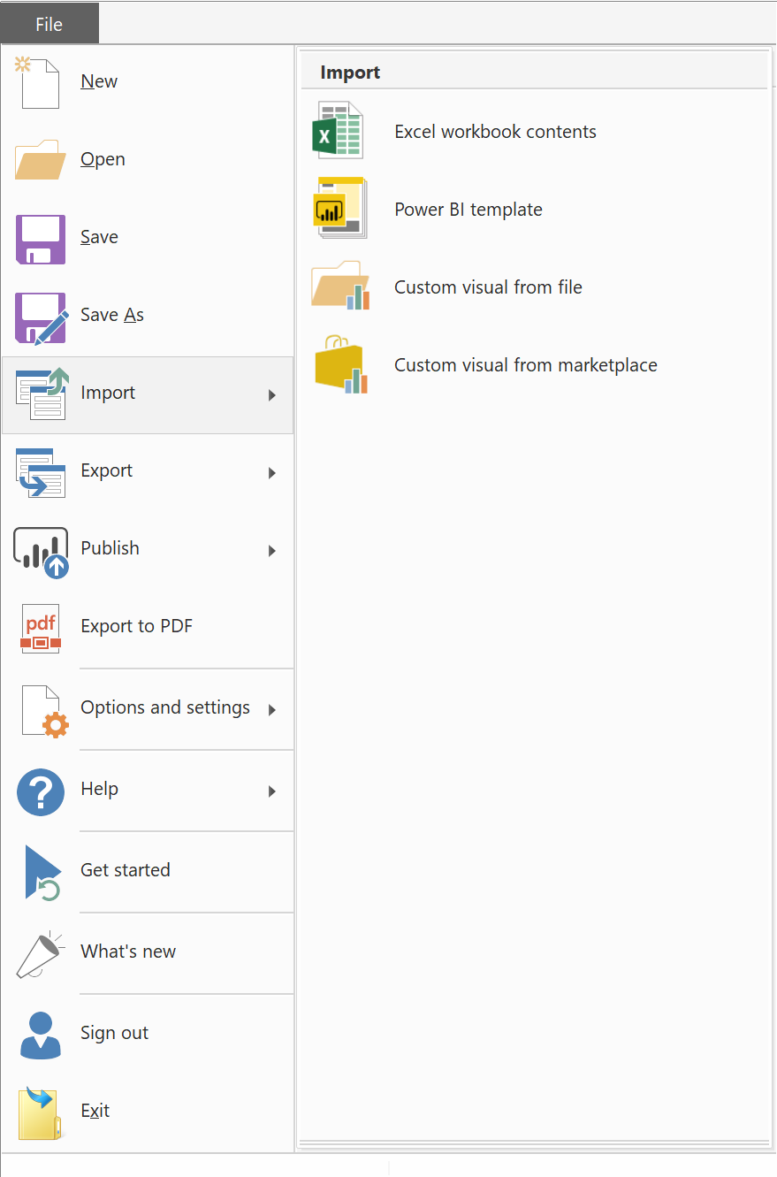

1. After importing the Power BI template, cancel/close out any prompts asking you to connect to an existing data source.
2. Click on Get Data, select “SharePoint Folder”, and click Connect

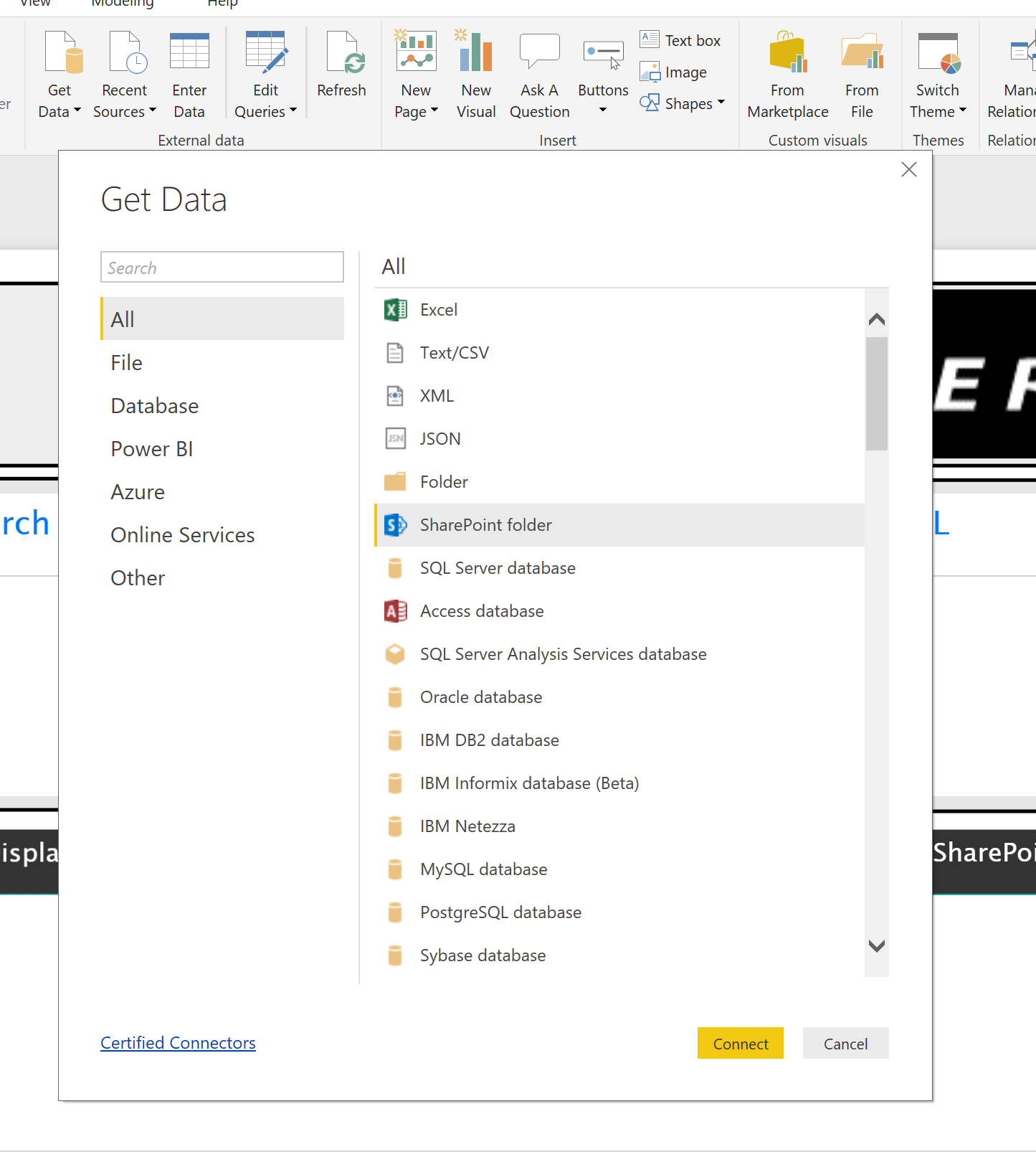

1. Enter the root URL for the SharePoint site you stored your CSV reports on and click OK

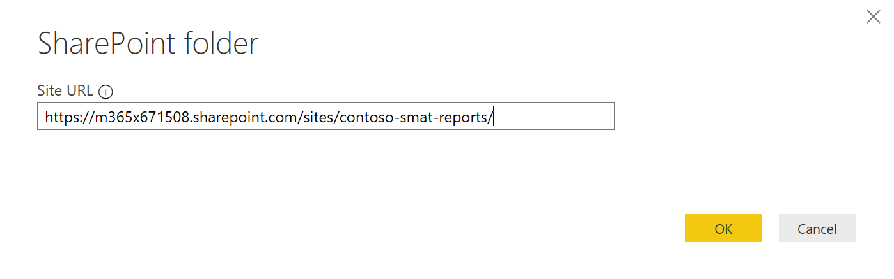

1. Choose the credentials you would like to use to create a connection to the SharePoint site with. These can be changed at any time, but ensure you are connecting at the exact site where the CSV reports are stored.
2. Before loading this data, ensure your CSV reports show as possible data repositories to load from and then click **Edit**

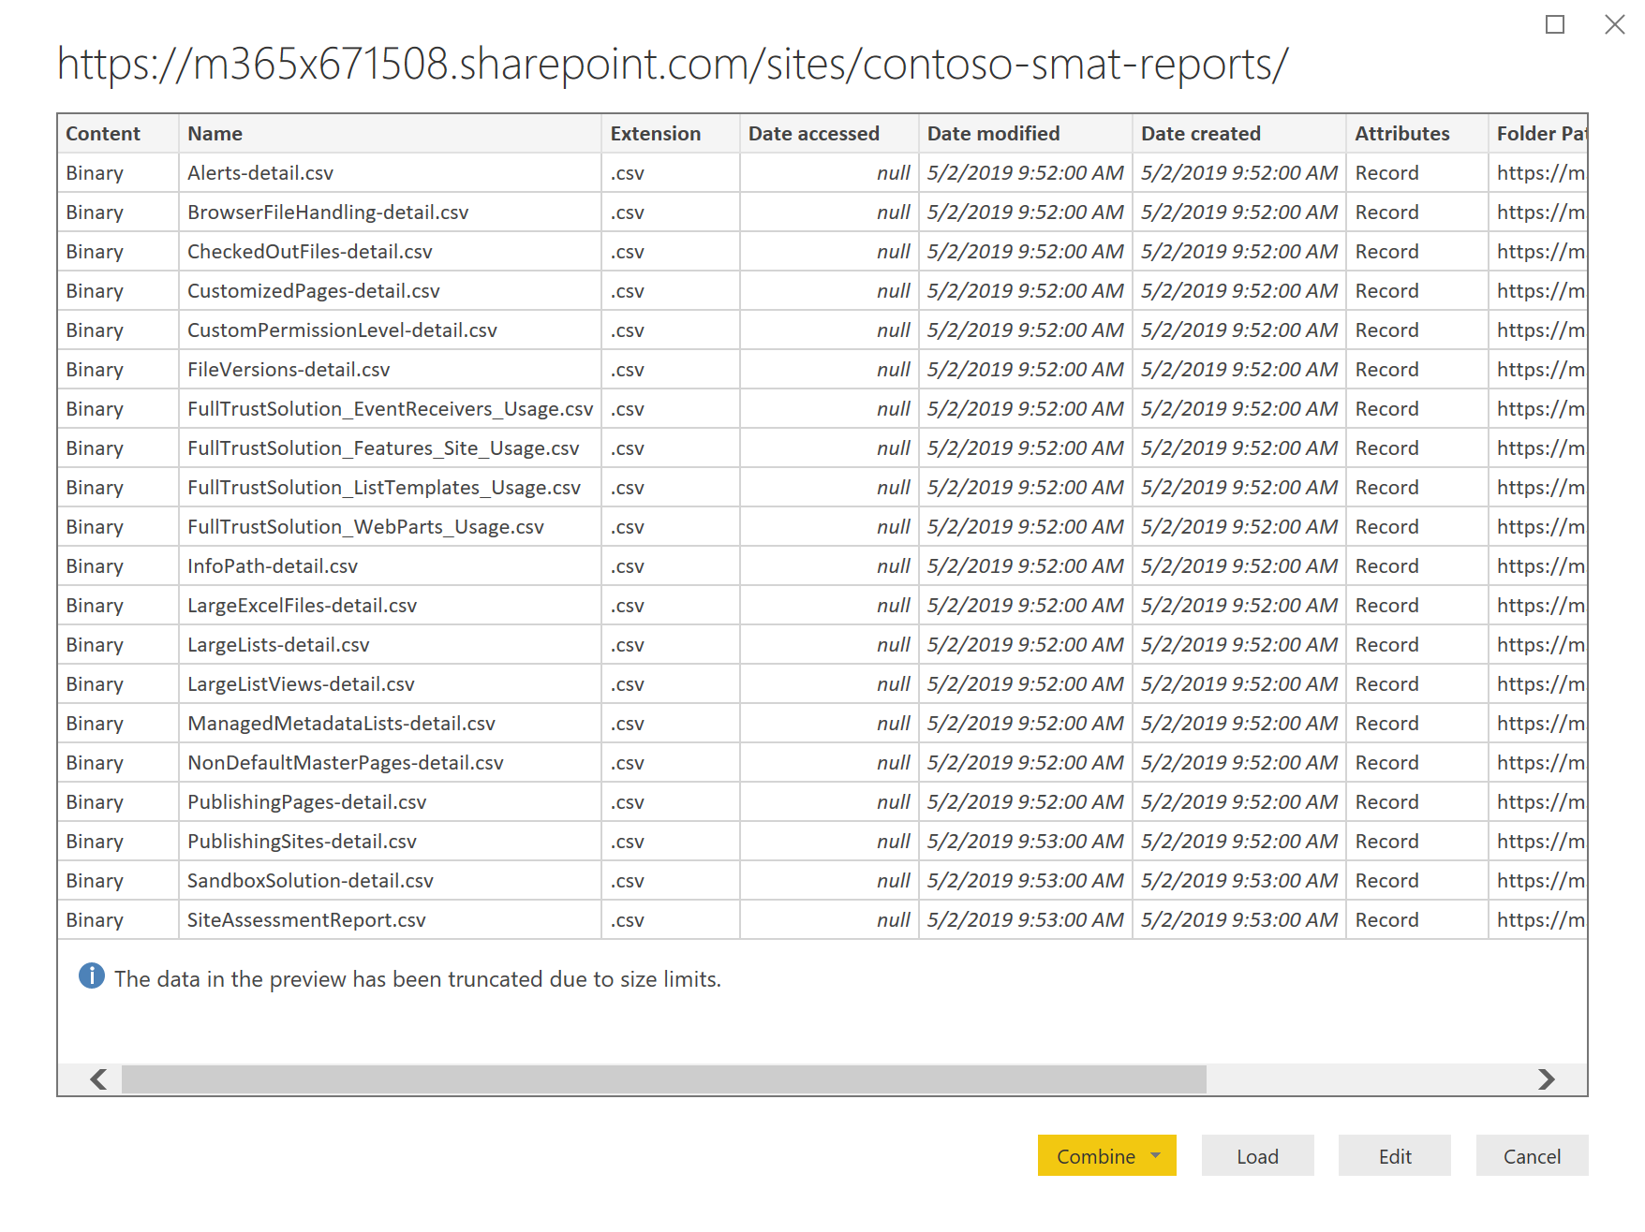

1. Click on the **Binary** link under column *Content* for the **SiteAssessmentReport.csv** report. This will expose all of the data inside of the <FILE-NAME>.csv report.

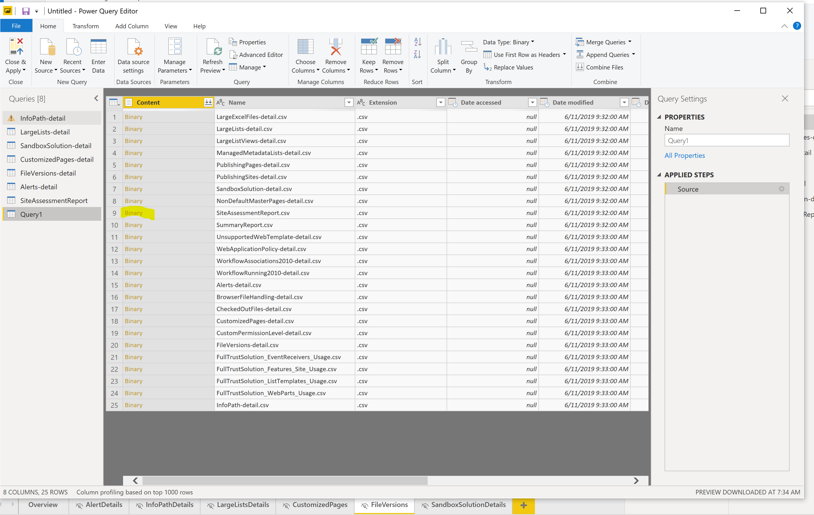

1. Click **Close & Apply** button. Leave the name as Query1. Remember the report name you loaded (SiteAssessmentReport).
2. Click on **Edit Queries,** edit queries, select the existing report SiteAssessment from the left navigation and **delete** it. Note: we are deleting this report from the list so we can re-name Query1 as SiteAssessmentReport. Since that report already exists as part of imported template, we have to manipulate data this way.
3. Now click on Query1 and rename it SiteAssessmentReport.
4. Click on **Close & Apply.**
5. Repeat steps **4** through **11** for every report in the SMAT file.

**Example**:

After you have loaded SiteAssessmentReport, you want to load LargeLists-detail.

1. Click on **Get Data**
2. Select **SharePoint folder** as your data source
3. Connect to your site where you store SMAT reports (site URL, not folder)
4. Once all reports load, click on **Edit**
5. Next to the report you wan to load, click on **Binary** (in this case, I am loading LargeLIsts-detail)
6. When report loads, click on **Close & Apply** (leave name as Query1)
7. Click on **Edit Queries** 🡪 Edit Queries
8. Select LargeLists-detail report from the left nav
9. Delete it
10. Select Query1 report
11. Rename it “LargeLists-detail”
12. Your final view in Power BI desktop should only contain queries for all CSV files..

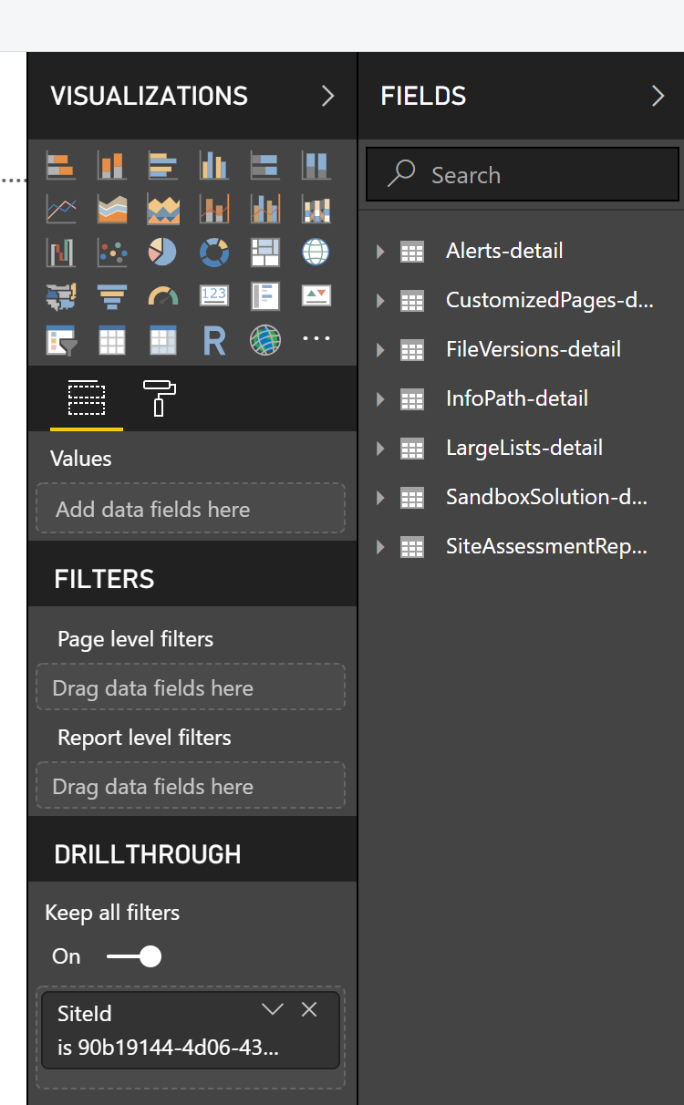

1. If data from these queries is not immediately loaded into the report, click on the **Refresh** button to force a data refresh.

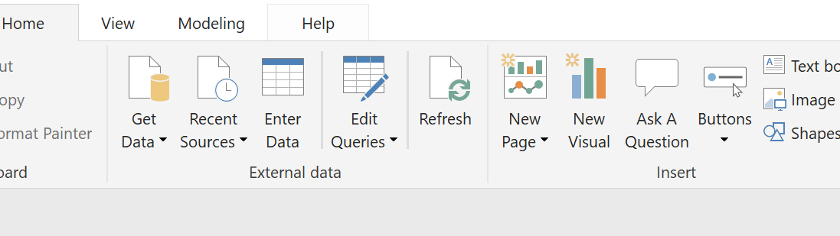

1. Now we are ready to publish this Power BI report. From Power BI desktop click the **Share** button and select a workspace you wish to publish this report to. If you do not have a workspace created yet you would like to publish this report to, just go to your account in Power BI Online and create a workspace from there.

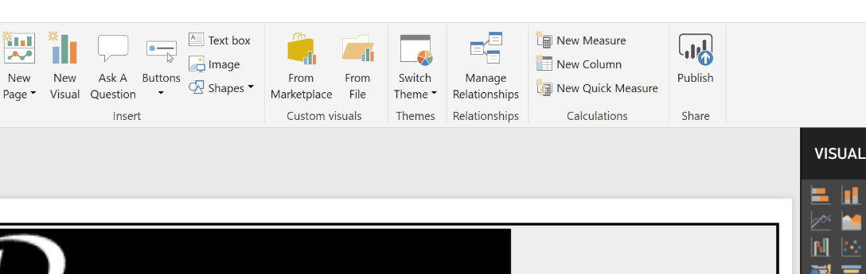

1. With your Power BI report now published, you will perform all of the next steps in Power BI Online. Login to Power BI Online and navigate to the workspace you published the report to.

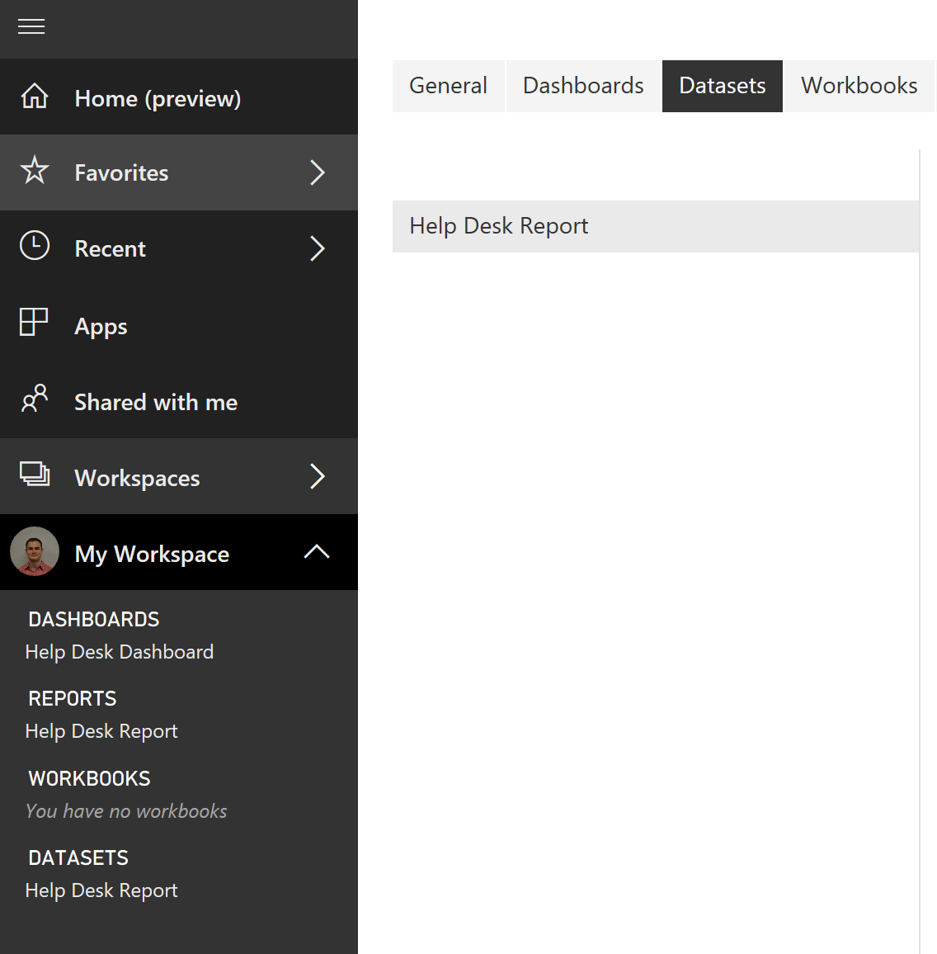

1. Now we are going to set a scheduled refresh on your dataset to ensure the data displayed in your report stays up to date. Hover over your dataset and click on the three dots that appear to the right.

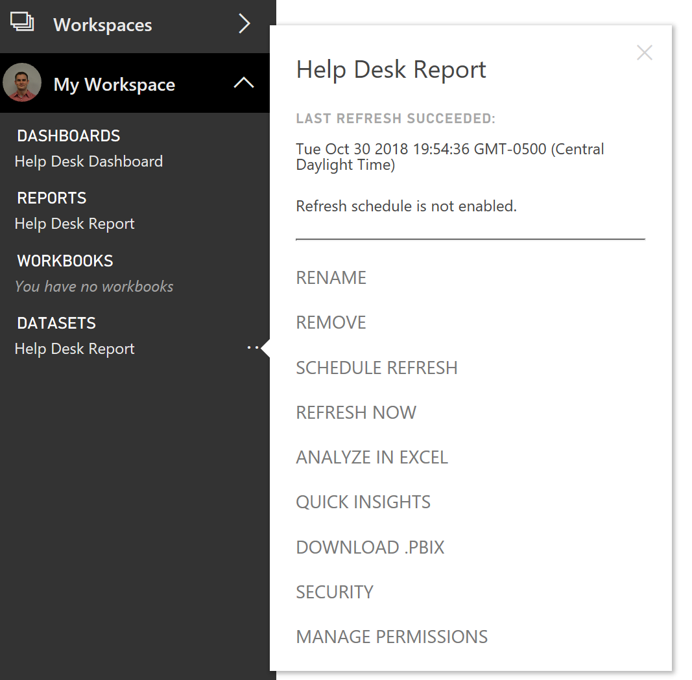

1. Next, click Schedule Refresh



1. Enable schedule refresh and select the **Refresh Frequency**, **Time Zone**, and **Time** you would like this data refresh to occur and click **Apply**

